From: Gan Chai Chuan (Top Glove - F9)
Sent: Monday, May 31, 2004 11:31 AM
To: _ALL Marketing (49 users); David Lim (hooisinlim@aol.com); Dorothy Ressel (ressel@attglobal.net); Egon; Edwyn Poon Yew Hong; Edwyn Poon (E-mail)
Cc: _ALL Compounding (22 users); _ALL Documentation (14 users); _ALL Packing (15 users); _ALL Production (48 users); _ALL Purchase (23 users); _ALL QA (19 users); _ALL Shipping (15 users)
Subject: int: MEMO - Monitoring on Letter of Credit (LC) Discrepancies REVISED 1
MEMO

To : All Marketing
From : Mr. KM Lee, Director / GM
Cc. : Dr. Lim, Wee-Chai, President / MD
Date : May 31, 2004
Subject : Monitoring on Letter of Credit (LC) Discrepancies
Reference No. : LKM/GEN/064/04
___________________________________________________________________________________________________

Reference is made to the above subject and in line with the current cost cutting program that the company is embarking on.

Append below are some of the most basic common discrepancies that we can find in the LC. Please take note that these discrepancies have hidden costs and the company has been paying thousands of ringgit as discrepancies charges.

The following are the most commonly made mistakes/ oversights:-
1) Late presentation of LC.
2) Validity of LC has expired.
3) Short Shipment
4) LC discrepancies due to OIC or relevant dept's negligence, such as Production, Packing, Shipping.
5) 3rd party BL an documents.
6) Shipment effected from.
7) Late shipment.
8) Transshipment evidenced on BL.
9) Description of the goods in the invoice does not correspond with the description in the Document credit.
10) Partial shipment effected.
11) Installment shipment not shipped within the period allowed for the installment.
12) LC expired.
13) Inability to provide copy of certificates required.
14) Short shipment.

Training or reminder letters will be issued (depending on the seriousness of the issue) with fine to the respective officers without compromise.

Attached is the full list of LC discrepancies that we can find in the LC.

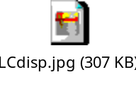
To maximize cost effectiveness by minimizing mistakes in our export documentation or trade
financing (possible savings on financing cost), attached please find ways to avoid charges together
with the follow- up action plan on LC as advised by our banker.

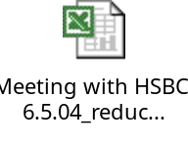

Please be guided accordingly.

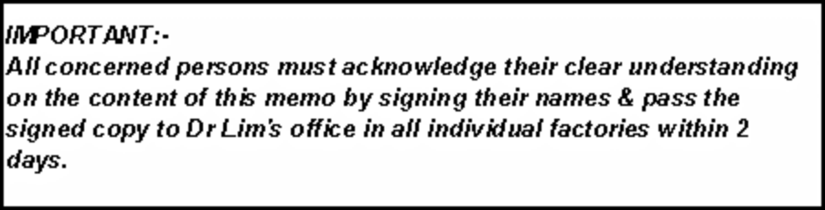
CONTINUOUS IMPROVEMENT AND INNOVATION ARE OUR DUTIES

Best regards,
Mr. KM Lee
General Manager
cc: Dr. Lim, Wee-Chai, President / MD lkm/gan/52504

